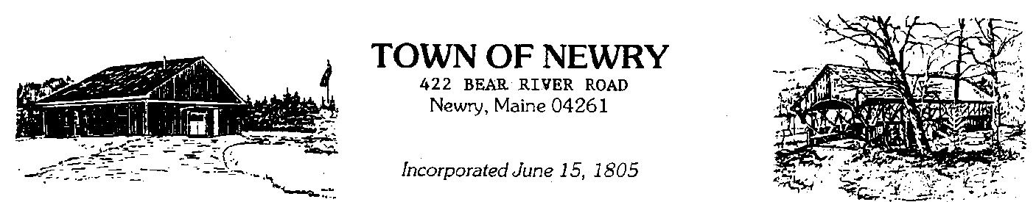

207-824-3123

APPLICATION FOR SIGN PERMIT

DATE: _____________ SIGN NO: ______________

APPLICANT NAME: _________________________________________________

BUSINESS NAME: ___________________________________________________

ADDRESS: _________________________________________________________

PHONE: _____________________ EMAIL: ____________________________

PROPOSED LOCATION RELATIVE TO LOT LINES AND BUILDINGS

INCLUDE A SCALED DRAWING ON THE REVERSE SIDE OF FORM INDICATING

SIGN COLORS TO BE USED, LIGHTING TYPE

SIGN DIMENSIONS & HEIGHT

FEE: $______________

PERMIT ISSUED ON: __________________

APPROVED BY: _______________________________________DATE: _________